Human arm impedance estimation in a rhythmic human-robot interaction

CODE COULEUR : Texte : auto plagiat Texte : question/commentaire

Introduction
Humans are capable of tailoring their limbs’ dynamic properties [Tsuji 2008, Burdet 2001, Milner 2005] to achieve stable behaviour with a wide range of environments, while insuring dexterous performances. Understanding and reproducing some properties of the humans’ interactions during various tasks is not only relevant to understand the emergence of perturbed goal directed movements but also for the design of innovative robot control.
The mechanical impedance of human limbs has been studied for decades under the control prism [Mussa-Ivaldi 1985] and is still an active research topic [4], [5]. The notion of impedance relates kinematics to forces, allowing the modelling of human movements during physical interactions. Despite their limitations [Kistemaker], elementary models, such as mass-spring–damper (KBM or KBI) or Hill-type have been shown to approach human behaviour [Tsuji 2008] and performances [KP Tee].
These models do not intended to explain the complete human motor control, but rather reproduce some of its aspects. More complete models [Guarin 2018] are required to understand the human CNS. Indeed, as explained by [Lastash 1993], to account for passive muscle visco-elastic properties, as well as for active behaviours induced by reflexes and motion, a single joint would at least need 13 parameters, making it very sophisticated and almost impossible to study multiple joints impedance during movements.
The use of less elaborated model has been widely chosen [Dolan 1993, Erden 2005, Tsuji 2008, Burdet 2001]. It allows authors to study the impedance during movements of multiple joints [Burdet 2000, Erden 2015]. Decoupling simple model from biological considerations to study movements at the endpoint level with a behavioural approach, even allowed to analyse performances, expertise [Erden 2015], learning [Burdet 2001, KP Tee 2003] and exploration [Li 2017].
The mechanical impedance cannot be directly measured and requires perturbing the limbs for estimations, or at least for calibration when using electromyography sensors []. Two configurations can be easily distinguished: on one hand, static or isometric tasks [4], [6], where the unperturbed pose is well known and on the other hand, dynamic tasks, where ongoing movements make the estimation of the unperturbed trajectory more complex.
In previous work at the intersection of robotics, control and human movement sciences [13], the authors studied the human central nervous system during cyclic movements in a simulated benchmark task. They were able to reproduce human-like performances using a Central Pattern Generator based control structure. An experimental test-bed was designed for impedance identification using an admittance controlled robot [14], and a methodology for impedance estimation during cyclic movements was proposed with preliminary results [ROMAN, +SB2021].
[Ajouter plusieurs paragraphes pour justifier l’étude des performances et des variations cycliques]
This paper presents the results of impedance estimation during a rhythmic task implying an interaction with a robot, with a wide number of participants (see section 2.3). Results are consistent with the literature [] and unveil significant cyclic variations of the endpoint impedance apparent parameters.

Material and Method
In this section, the ball-bouncing task, the apparatus used, the experimental protocol and the methodology proposed for impedance estimation are presented.

Ball bouncing task
[?? Présenter les retours haptiques qui n’ont pas été décrits, faute de place, dans les derniers papiers]

Apparatus
Figure [] depicts the experimental test-bed used for the experiment. Participants were standing in front of a table supporting the KUKA youBot 5 DOF robot, that had its first and last joint positioned controlled to fixed orientation, so that the robot would only evolve in the sagittal plane of the participants. The other three joints are admittance controlled at 1kHz, as detailed in [CASE], so that participants can move the robot along a vertical line without feeling the weight of the robot, nor friction of the joints, and with a reduced apparent inertia [LAMY]. Forces of interaction are measured using a 6-axis force/torque sensor ATI Mini 45, placed between the robot endpoint and a handle that the participant manoeuvre. The data from the sensor is sampled at 1kHz. For the control, the endpoint position of the robot is obtained using joint data. However, to limit bias coming from joint flexibility, a motion capture system V120:Trio by Optitrack, allows to acquire the handle position with a submillimetric accuracy at 120Hz.
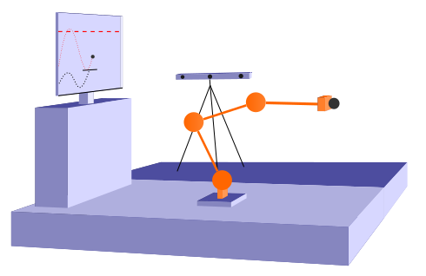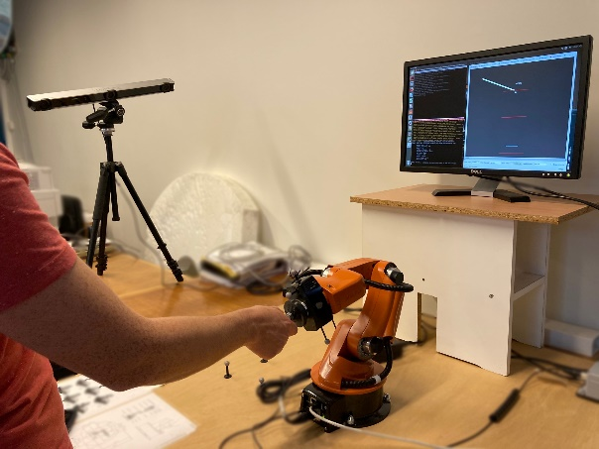

Subjects
31 participants took part in the experiment, with an exclusion of persons subject to motor disorders. Among the participants, 25% were women, 10% were left handed, and 40% had already manipulated a similar robotic system and 30% had never interacted physically with a robot. They were on average 30 years old (+/-8.6), and declared height of 176.2cm (+/-9.3) and weight of 71.3kg (+/-12.7) on average.

Experiments
The experiment occurred during two sessions on the same day (for all but three participants) separated by at least 45min. Each session lasted 30min on average. The first part of the first session served the purpose of familiarising subjects with the test-bed and the protocol. When confident enough with the ball-bouncing task and the robot, two trials of 5min each were conducted with a small pause in between. The first session was then over. The second session was used for three others trials of 5min each, still separated by small pause to minimise fatigue. Two experiments were randomly attributed to the first two trials of each session for every participant, so that participant executed either Experience 1 or Experience 2 during the first session, and the other during the first two trials of the second session.
During all trials, participant had to operate the robot handle to move a paddle in a digital environment were the ball-bouncing task was simulated. Their goal was to match the ball apex position with a target height h*, the target position was constant during each trial. To help them reduce the bouncing error $\epsilon_r$ between the ball center at the apex, and h*, a score was displayed slightly above the target height. Participants were instructed to try to maintain a constant ball impact position z_k, during and between trials. During both experiences, the robot itself introduced perturbations, as detailed in [ROMAN?], that were timed from the ball impacts on the simulated paddle at three possible cyclic phases: 1) $\phi_1$ after the ball impact, 2) $\phi_2$ during the decreasing phase of the paddle and 3) $\phi_3$ before the next ball impact at the lowest velocity. These phases are shown on Figure []. Perturbations were randomly spaced between 2 and 5s.
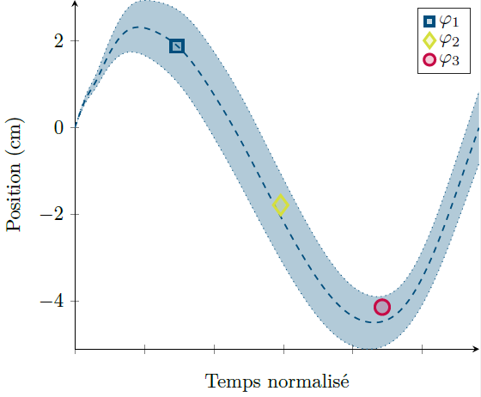

Experiment 1:
For the Experiment 1, the target height $h_2^*$ was fixed at 1.75m in the simulation, and perturbations were randomly split at the three cyclic phases $\varphi$ in all three trials. It is important to underline that the last trial of the second session was always the last trial of this experiment, whether or not the participant started with Experiment 1.

Experiment 2:
Experiment 2 was only composed of two trials. A target height of either 1.5m ($h_1^*$) or 2m ($h_3^*$) was randomly attributed to each of the two trials, to minimise the influence of order. In this experiment, all perturbations arised at phase 1 $\phi_1$.

Data analysis
With 31 participants, 155 trials were conducted during 62 sessions that represent more than 14h of recording, without considering familiarization. All data acquired was interpolated on a time vector sampled at 1kHz. The unbiased position from the motion capture system was transformed to the robot base by minimising the quadratic error with the endpoint position computed from joint data [absor ref ?]. Both the position and force were filtered using Butterworth second order digital filters with respective cutoff frequency of 25Hz and 50Hz. Cycle are defined using ball impacts.
To compute virtual position and force, necessary for the impedance estimation, two different methods are used. The virtual position is approximated using spline interpolation with a window of 215ms chosen to minimise quadratic error with an unperturbed trajectory as well as maximising duration [evaluation de la méthode ??]. The virtual force is approached using a sum of sines optimisation with a masked window of 100ms after the perturbation [ROMAN] [evaluation de la méthode ??]. The parameters are then estimated using an ARX identification on a discretised impedance model (eq) [ROMAN] on an identification window of 150ms.
[Paragraphe sur les performances ?]
Each participant has several estimations for each experiment and each configuration ($h^*$ and $\varphi$). Data from Experience 1 is spread among the three trials, while data from Experience 2 can be separated by trials. From these estimations, medians are computed for every parameter since it proved to be more robust to errors than average values after taking out outliers [Dois-je prouver cette affirmation?]. This way, each impedance parameter is populated with 93 estimations ($31$ participants $\times 3$ phases) for Experiment 1, and with 62 estimations for Experiment 2 ($31$ participants $\times 2$ target heights).
In the following study, analysis of variance (ANOVA) were performed with a threshold of 5%. Post-hoc tests were proceeded using the Bonferroni correction.

Results
In this section …

Performances
To analyse performances, two criterions were used for each participant: 1) the precision defined by the average bouncing error $$, 2) the repeatability defined by the standard deviation of the bouncing error $$.

Perturbations:
The robot itself introduced perturbations as seamless as possible, while providing deviation sufficient for impedance estimations [ROMAN]. After the two experiments, and even if participants were warned of the presence of both haptic feedback and perturbations, only 55% declared having felt perturbations during at least one the trials (the question was asked at the end of each session). To substantiate either the absence of effect of perturbations on performances or the opposite, cycles before a perturbation $c^{-1}$, and cycles one to three cycles after ($c^{1}$, $c^{2}$, $c^{3}$) were compared, for all trials.
A mixed designed ANOVA was conducted on $\mean{\epsilon}}$, with the main factor being cycles position (4 conditions), and the random effect being the experiment (2 conditions, either Experiment 1 or 2). A significant effect of the main factor was observed F(3, 180) = 6.8, p<0.001, eta^2=0.026, no significant interaction nor random effect were observed. The post-hoc analysis shown on Figure [] reveals that the only significant difference comes from $c^{1}$ with all other cycles, with a mean difference of 2cm. The mean bouncing error is therefore slightly higher right after a perturbation, while no differences are observed between other cycles.
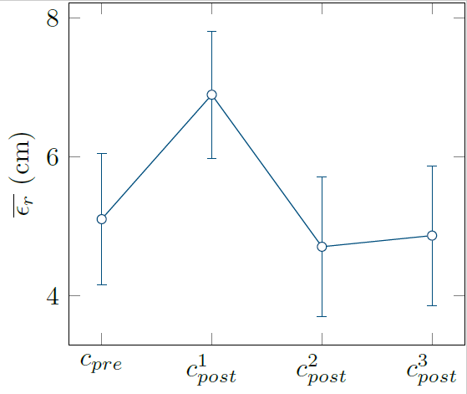
A second mixed designed ANOVA conducted on $\sigma(\epsilon)}$ with the same factors had to be corrected with Huynh’s method [ref] since Mauchly's sphericity test [ref] was not verified. The test unveiled no significant effect of the main factor F(2.6,158)=1.5, p=0.23, eta^2=0.005, neither of the random effect nor interactions. The repeatability of the bouncing error was therefore similar for all cycles, with an average standard deviation of 25cm.

Target height
[Dois je faire un passage sur l’Expérience 2 ? en sachant qu’aucune différence n’est après observée sur l’impédance ?]

Individual performances
[Je pense que même si aucune différence n’est observée pour cette répartition sur les paramètres en impédance, il est important de faire un passage sur ce point puisque des différences significatives sont observées par d’autres auteurs]

Impedance parameters

Target height
[Pas d’effets]

Cyclic phase

Discussion
[Les perturbations ne provoquent Presque aucune degradation des performances]
[Contrairement au résultats de Erden&Billard et Burdet, pas de différence d’impédance liée aux performances => contrôle actif plutôt que passif ? (Morice)]
[Hypothèse confirmée pour les variations intracycliques ? + interprétations de ces variations]

(Conclusion ?)

